College Library Management System

*Wireframe Documentation*

Registration Page

Registration page let user to create account and behind the scene user data will stored in DB.

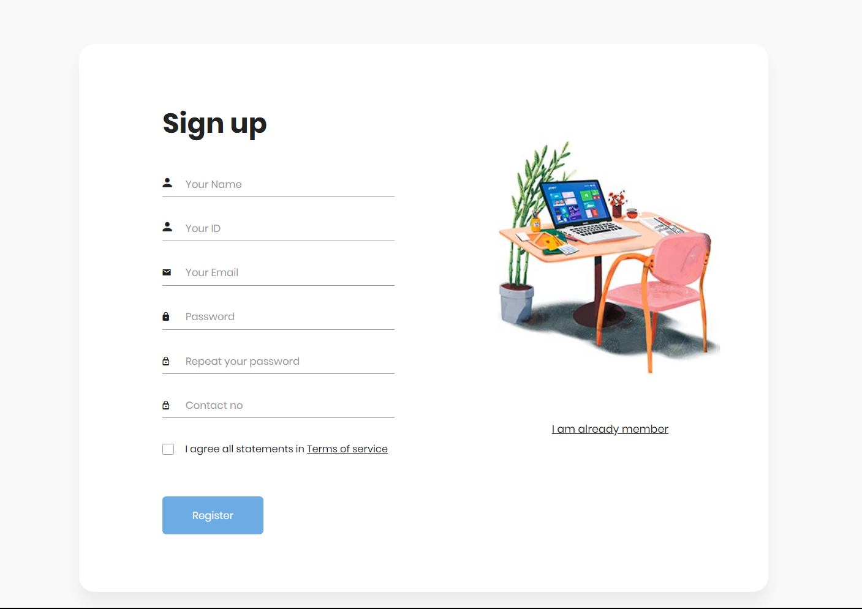

LOGIN PAGE

Login page let user to logged into the account based on their authentication and view.

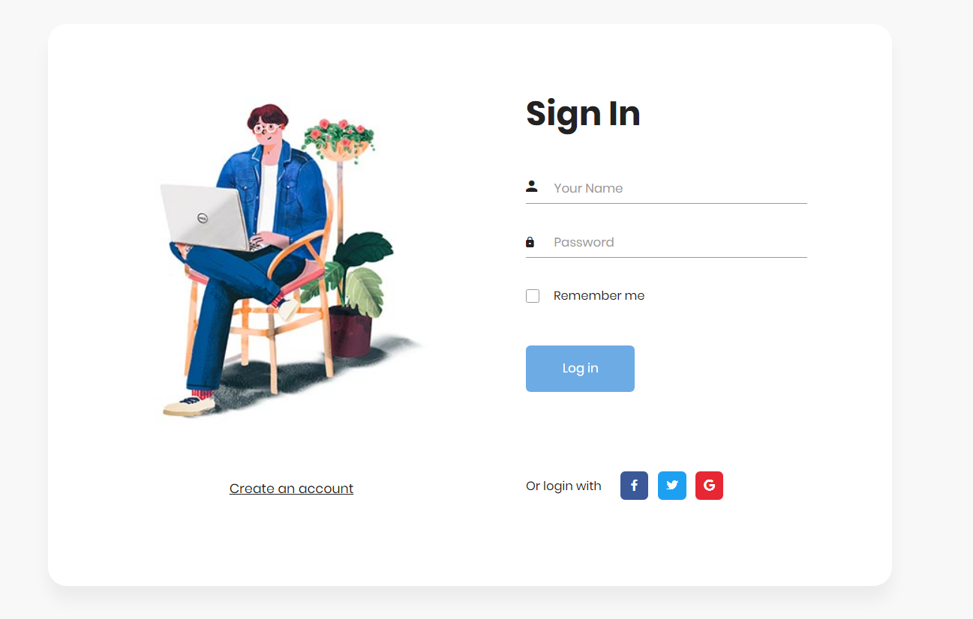

ADMIN PERSPECTIVE

After logged in Admin can have different options to perform and control items, all the required operations is provided based on their role.

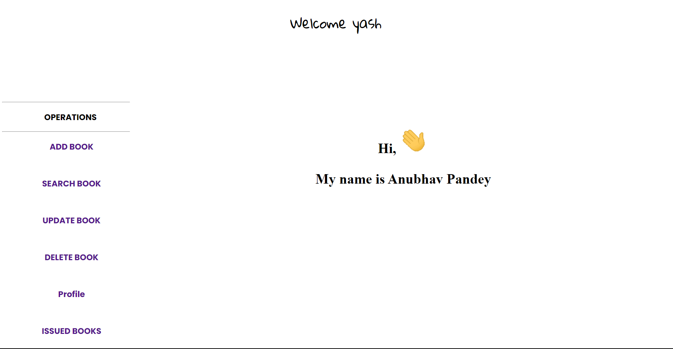

1. ADD BOOK :

Add required details in the fields to add book , also need to add image of book , that will all get stored in DB.

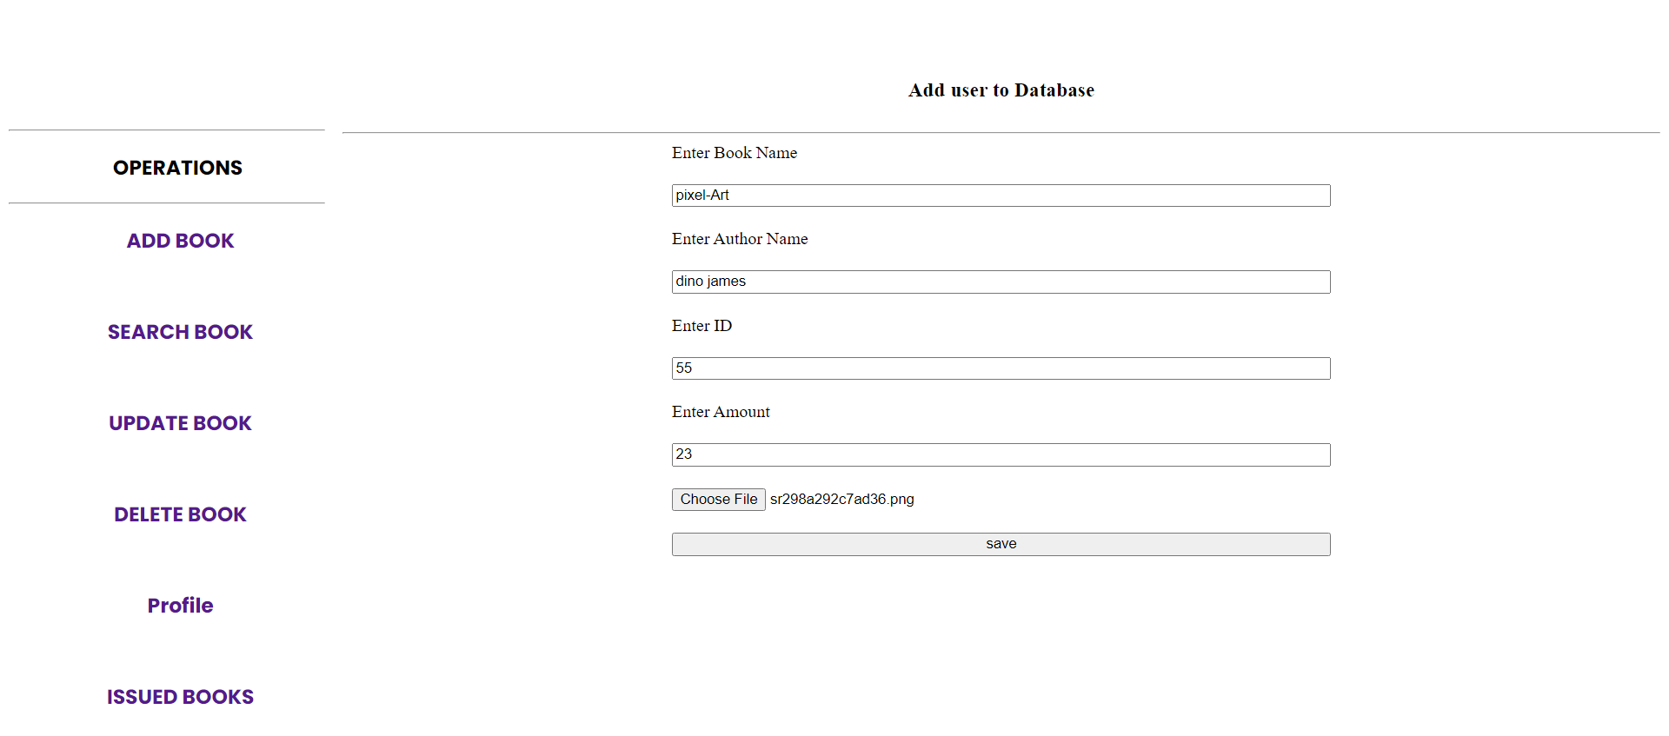



1. Search Book :
2. Already List of book will fetched in the JSP with images for ease of user to find book even with name.
3. User can search book by their name or author name by using search option.

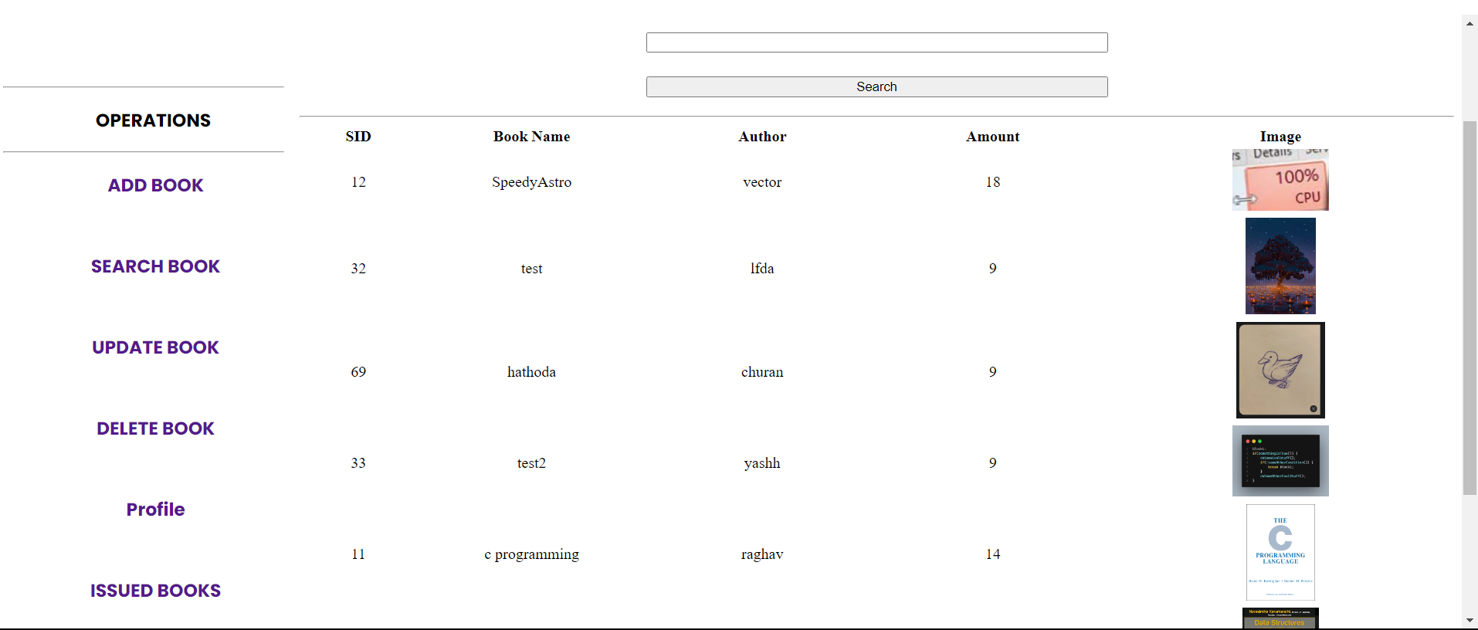

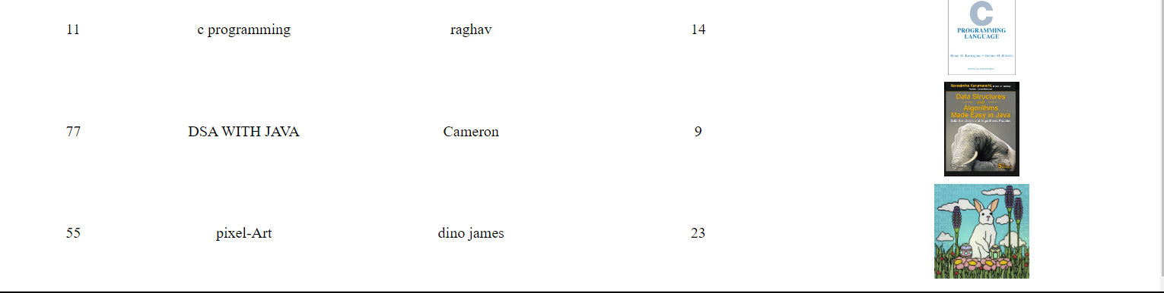

1. UPDATE BOOK :
   1. Already List of book will fetched in the JSP with images for ease of user to find book and update its properties.

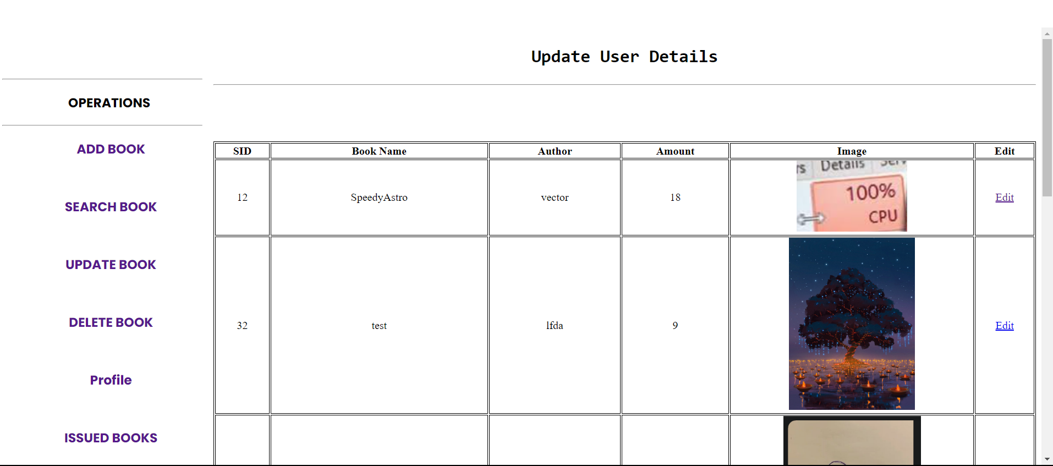

* 1. EDIT Option let user to next page, where user can edit name, author name, image, amount etc.

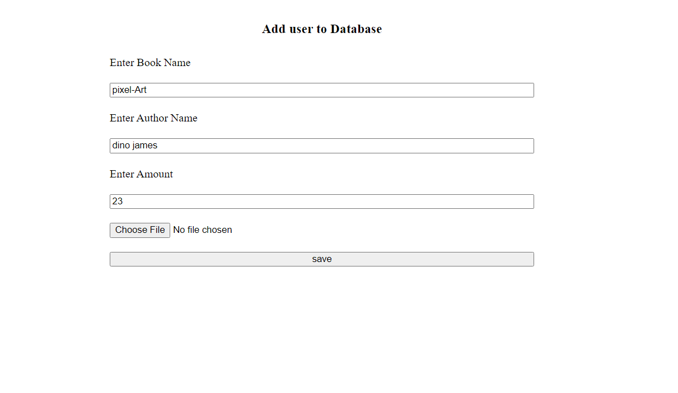

* 1. Any new changes will get saved or not changed properties will remain same as a default.

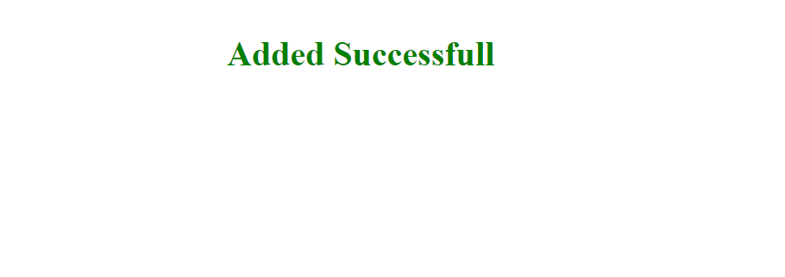

1. DELETE BOOK :

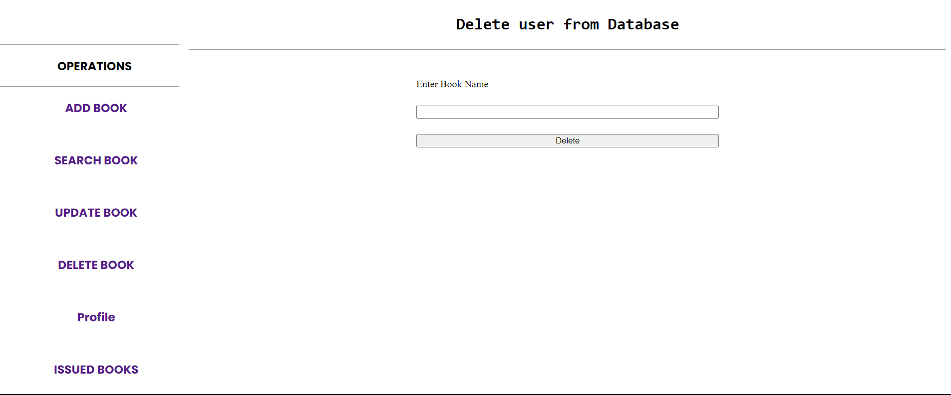

Add book name in the field, book will get deleted from database.

1. ISSUED BOOK :

Its fetch the records from the DB , if any student issue a book a new record will get to add into this list, so admin can return book by their account.

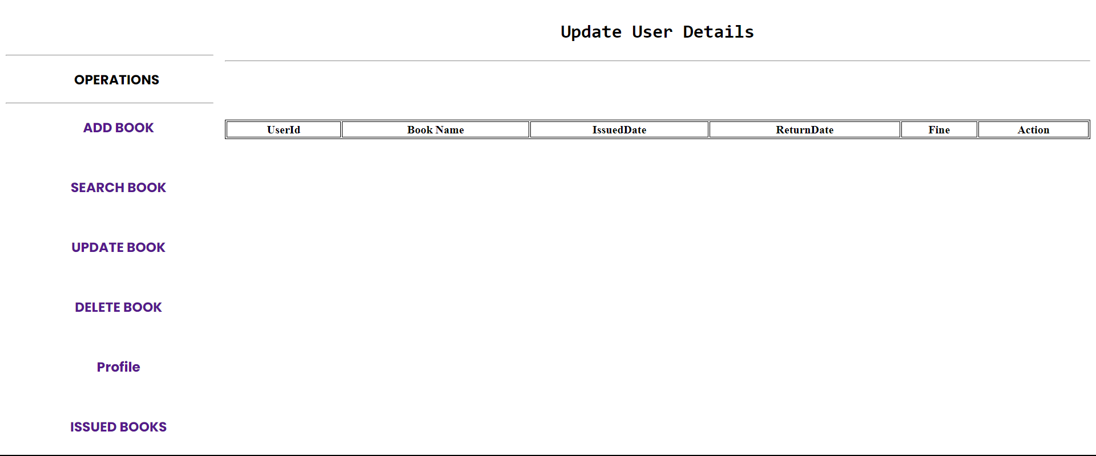

STUDENT PERSPECTIVE

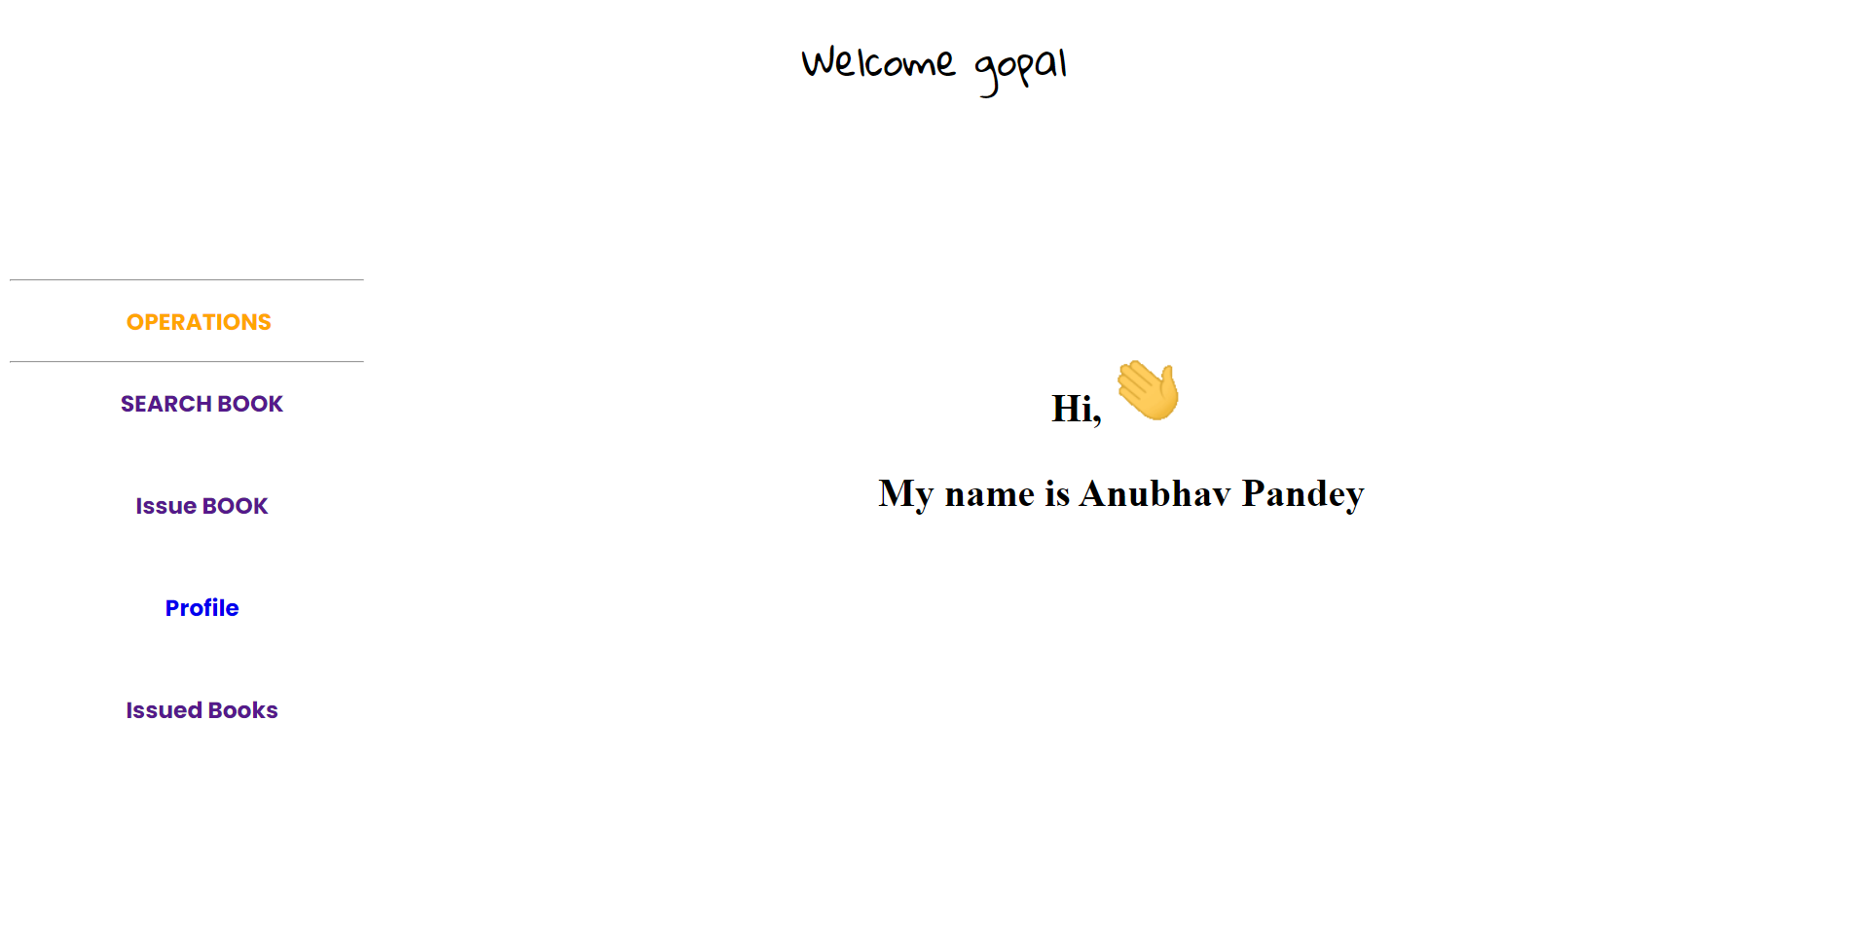

As of Admin, user can logged in as a student and can have operations given of what a student required to work around.

There are 4 options given:

1. Search Book
2. Issue Book
3. Profile
4. Issued Book
5. SEARCH BOOK :
   1. Already List of book will fetched in the JSP with images for ease of user to find book even with name.
   2. User can search book by their name or author name by using search option.

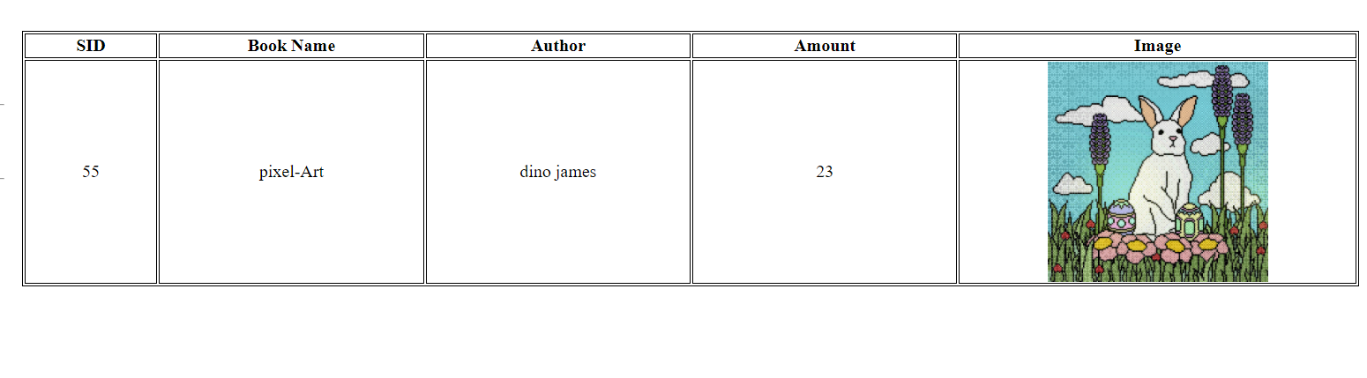

1. Issue Book

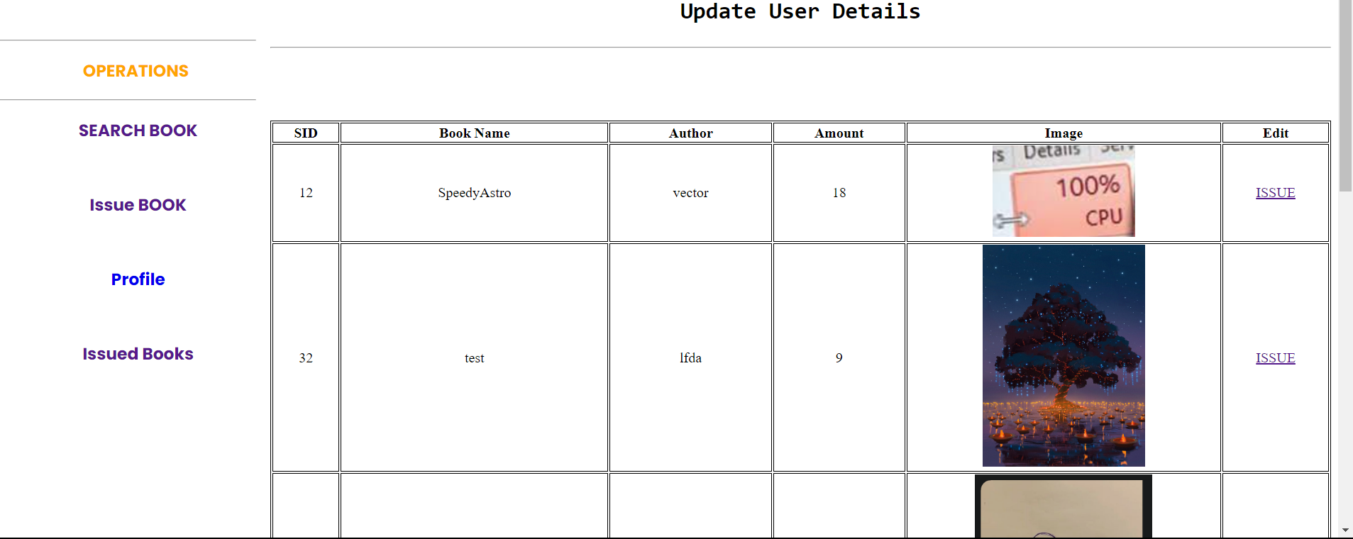

Student need to just click on Issue hyperlink, and that’s it book is been issued and behind the scene issued book is saved in DB along with user id, issued date, and expected return date, if return date is exceeded than fine will be added based on the number of days.

